Login to PLYSSQL147P.

Open SQL Server Management Studio.

Select the database **Allergan.**

**Generating History Data:**

1. Run the below query.

This will display the latest Data Month name for Germany. Here, latest month is M112012.

select * from Allergan_Load_Details where country = 'DE'

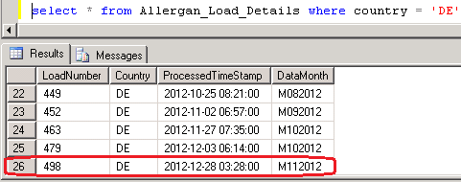

2. Run the Below query with the Latest Data Month Load Number.

This will display the backup data of M112012 Which was loaded in last production run.

select * from Allergan_Output_History where loadNumber = 498

3. Run the Below SP which will load the latest production period data from Production

Server (PLYSSQL147P) to Development Server (PLYSSQL146D)

EXEC dbo.usp_Populate_History_Data 'DE','MmmYYYY'

where mm = Current Production Month Number (01, 02, ... 11,12)

and YYYY = Current Production Year.

4. Run the below query to check whether the latest production period data loaded or not

select * from Allergan_Load_Details where country = 'DE'

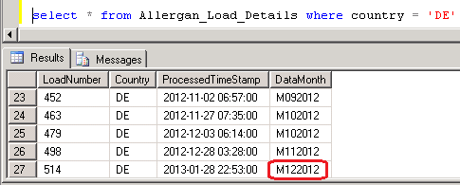

5. Run the **MergePacks.exe** from D:\FTP\MergePacks tool\

6. Click on Build Report

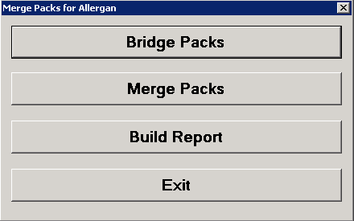

7. Select Country = DE and Previous Build = Previous Month. Click OK

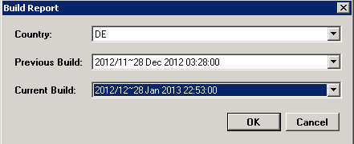

8. After successful run Below window will appear and the History Correction Report will generate at D:\FTP\MergePacks tool\Reports

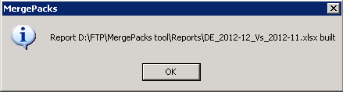

9. Copy the report file and backup at D:\FTP\MergePacks tool\Reports\YYYY\YYYYMM

where MM = Current Production Month Number (01, 02, ... 11,12)

and YYYY = Current Production Year.

10. Download the history excel file into Local and rename

History_Corrections_Germany_monYYYY.xlsx

where mon = Current Production Month Name

and YYYY = Current Production Year.

This file should mail to Allergan with delivery mail.

**Input CUBE vs Output Data:**

1. Andrea/Abhay will mail the input SA Cube **PHARM AL A RSO C34000_31__YYYYMMDD.zip** by mail which should be load in 162.44.12.72 server

2. Login to 162.44.12.72 server.

3. Copy the output file **Germany_MMYYYY.csv** from production server (PLYSSQL147P) D:\FTP\Allergan_Production_Output\Renamed_Outputs and paste at the location \\162.44.12.72\d$\Allergen\Germany\YYYYMM

where MM = Current Production Month Number (01, 02, ... 11,12)

and YYYY = Current Production Year.

4. Open **Database Installer** from **Start -> All Programs -> IMS Health**

5. Click **Select** and select the cube PHARM AL A RSO C34000_31__20121109.zip and click **Open**

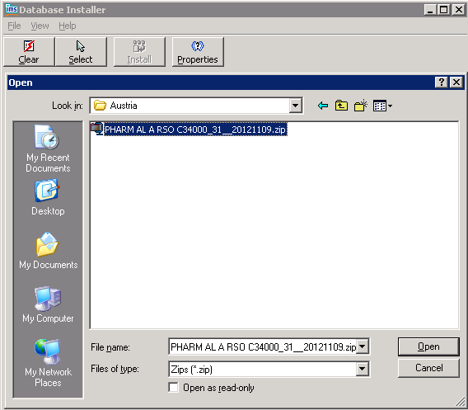

6. Select the Cube and Click **Install**

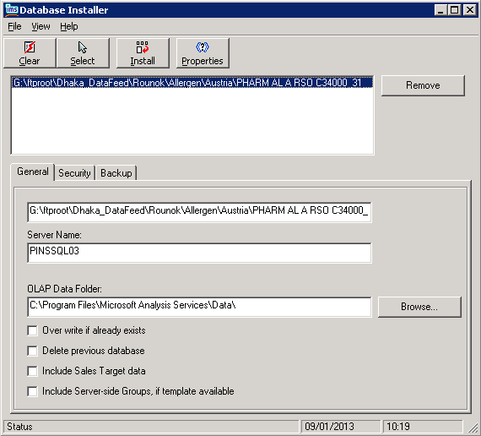

7. When the cube loaded successfully below message window will appeared.

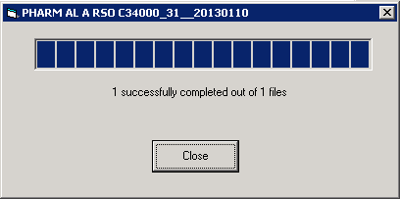

8. Open **Analysis Manager** from **Start -> All programs -> Microsoft SQL Server -> Analysis Service**

9. Select the required Cube and Click **Data**

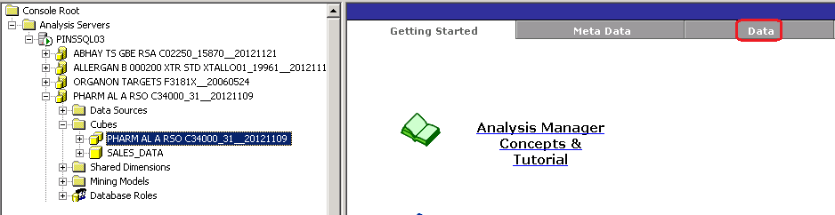

10. Below window will appear. Click ok to Continue

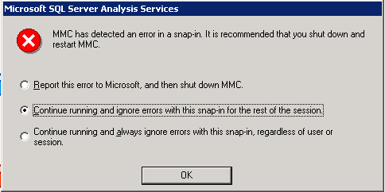

11. Click **Data** again.

12. From Period select the latest production period

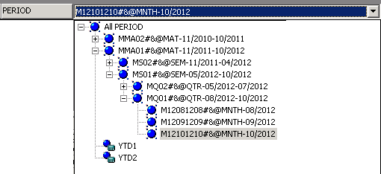

13. Drag the Product.MKT to the Result Area. This will remove the Geography

|  |  |
| --- | --- |
|  |  |

14. Open the output csv file **Germany_MMYYYY.csv** with Textpad. Select 2 records for 2 measure Units and Values for a particular Product and SKU which have >0 values in latest month

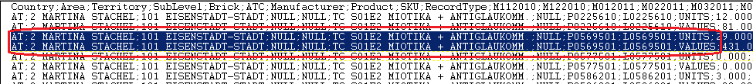

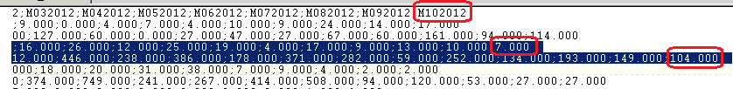

15. Copy the records and paste into a new text file and save the file as QA_Germany_YYYYMM.txt at the location G:\ftproot\Dhaka_DataFeed\Rounok\Allergen\Germany\YYYYMM

where MM = Current Production Month Number (01, 02, ... 11,12)

and YYYY = Current Production Year.

16. Select the Area , Territory and Brick from **Geography.Geo** according to the input record

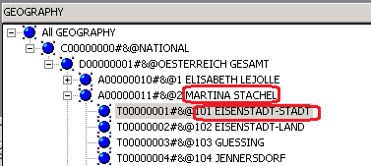

17. Select Market, Products, Packs from Product.MKT according to the input record

---------------------------------------------------------------------------------------------

Nb: Select p.prod_code_id,p.product,i.product_code,i.product

From PRODUCT_CODE_ALLERGAN_GERMANY p, Allergan_GERMANY_S1E_Product_details i

Where p.product=i.product

And p.prod_code_id=

--------------------------------------------------------------------------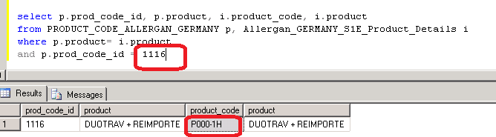

--------------------------------------------------------------------------------------------------------

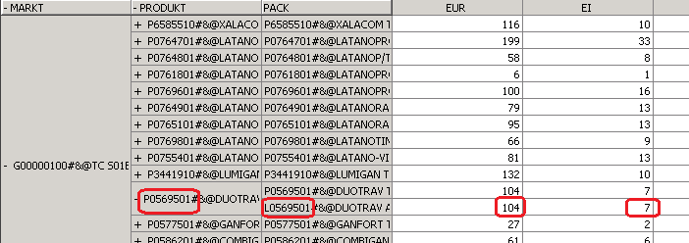

18. Match the value for input SA Cube and Output CSV.

**Summary File Checking**

1. Open the Summary File **GermanySummary.txt** from Production Server (PLYSSQL147P) from the location D:\FTP\Allergan_Production_Output with TextPad

2. Check the ratio with the Previous month vs Current month.

3. Check if the ratio decrease of previous vs current for any measure, rest 1 will decrease also

DE;S01E1 + S01E2;NULL;1116;UNITS;**19813.000;17227.000**

DE;S01E1 + S01E2;NULL;1116;VALUES;**935290.540;804343.420**

4. Check if the ratio increase of previous vs current for any measure, rest 2 will increase also

DE;S01E1 + S01E2;NULL;1457;UNITS;**31.000;49.000**

DE;S01E1 + S01E2;NULL;1457;VALUES;**1378.570;2179.030**